Dear All,

in May, Claus Kropp will organize an international conference on Draft Animals. FECTU is happy to contribute. Just have a look at this beautiful promotional video and don't hesitate to subscribe to the Newsletter.
very best wishes and a happy new year!

the FECTU board

Good morning everyone,

at the end of this year, I wanted to thank you for all the support concerning the global draft animal conference 2021. I think we can really push things forward with this and I already have quite a few ideas for future networking and projects – but thats for 2021.
For now, I gladly want to share with you our first Promo-Clip for the conference which was just published.
For the French version:
https://youtu.be/nHDivDOCtNM

For the English version:
https://youtu.be/TPbbu1XKvJg

For the German version:
https://youtu.be/90VVgFDlKjc

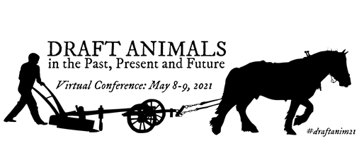

Other languages will follow in the upcoming days as the translations get ready and are implemented. I will send you a finalized list probably at the end of this coming week.

Please feel free to share the clips wherever suitable.

We also have a conference logo now and a hashtag: #draftanim21 :

Looking forward working with you next year.

All the best
Claus

